Test Project Module 4 / 競賽試題4
(Advertising and display design)（廣告和展示設計）
WSC2013_TP40_M4_actual_EN
Submitted by: Group 4

Susan de Guzman AE
Prenesh Naidoo ZA
Lee Troxell US
Ramón Elías López CO
Teera Piyakunakorn TH
Farid Zaryab IR
Mosaab Al-Awadhi KW

Contents / 內容

This Test Project proposal consists of the following documentation/files:
- WSC2013_TP40_MOD4_Actual_EN.doc (project brief)
- WSC2013_TP40_MOD4_01_EN.zip (folder of images for the task 1) (refer to Appendix 1.3)
- WSC2013_TP40_MOD4_02_EN.zip (folder of logos and colour palette for task 1 & 2)
(refer to Appendix 1.4)
- WSC2013_TP40_MOD4_03_EN.txt (required copy for task 1)
- WSC2013_TP40_MOD4_04_EN.zip (fonts)

這個競賽試題包含以下文件/檔案：
- WSC2013_TP40_MOD4_Actual_EN.doc (試題簡報)
- WSC2013_TP40_MOD4_01_EN.zip (任務一的圖片資料夾) (參考附件1.3)
- WSC2013_TP40_MOD4_02_EN.zip (任務一和任務二的標誌和色彩計畫)
(參考附件1.4)
- WSC2013_TP40_MOD4_03_EN.txt (任務一的文案)
- WSC2013_TP40_MOD4_04_EN.zip (字體)

Introduction / 說明

We are Sasol / 我們是Sasol公司
Sasol is an integrated energy and chemical company that leverages the talent and expertise of more than 34,000 people working in 38 countries. We develop and commercialise technologies, and build and operate world-scale facilities to produce a range of product streams, including liquid fuels, chemicals and electricity. Today Sasol has grown to become South Africa’s leading fuel provider and an international player in the energy and chemical sectors.
Sasol公司一個整合能源與化學的公司，其公司影響了超過34,000的人才和專家在38個國家工作。我們發展和商業化科技，以及建立和支配世界規模的設備來製造一系列的產品線，包含液態燃料、化學品和電力。現今的Sasol公司已經成長為南非供應燃料的領導品牌，以及一個能源和化工製造商國際型的角色。
The South African Sasol Solar Challenge / 南非Sasol 太陽能公司的挑戰
During September 2014, international and local teams will compete in the Sasol Solar Challenge, an epic two-week country wide endurance challenge involving engineered solar powered vehicles. Teams have designed and built their own innovative vehicles, which will be put to the test as they travel 5400 km across some of the most demanding terrain South Africa has to offer.
2014年9月，國際和在地的團隊將會一起競賽Sasol太陽能挑戰。一個長達兩週國際性的耐力挑戰，內容包含機械太陽能汽車。團隊必須設計和製造他們自己的創新汽車，這部汽車將被實際測試5400 km駕駛於南非難度較險峻的地形上。
Teams from around the globe will descend on South Africa to participate in the Sasol Solar Challenge, the South African leg of the international solar car challenge. Held every two years, this eco-efficiency challenge allows teams from around the world to congregate to demonstrate the sophistication and performance of solar powered vehicles bringing through leading technology.
來自世界各國的團隊，將會來到南非參加這項Sasol太陽能挑戰：南非區的國際太陽能汽車挑戰。每兩年舉辦一次，這項經濟效率挑戰歡迎來自世界各國的團隊齊聚一堂展示精緻和出色的太陽能電力汽車，引領其邁向領航的科技地位。
Ranked as one of the top global events of its kind, the Sasol Solar Challenge is an exciting competition aimed at educating people in the areas of science, innovation, teamwork and business principles. The challenge is a collaborative approach between scholars, students, private individuals and various industry and government partners that will see competitors come together to design and build their own engineering systems, and ultimately drive a solar powered vehicle cross country.
名列於世界著名活動之一，Sasol太陽能挑戰是一個有趣的挑戰，目的是為了教育人們對於這個領域的科學、創新、團隊合作和商業原理。這個挑戰集結獎學金、學生、個人和來自各方工業和政府單位，目的是希望看到挑戰者一起設計與建造他們自己的機械系統，以及最後能駕駛太陽能電力的汽車橫跨國家。
Solar power is flexible and can offer energy solutions across different applications to utilise in a carbon-constrained world. Developing alternative energy technologies, such as solar will contribute to the worlds transition to a low carbon economy.
太陽能源應變性高，可以為不同的情況提供能源的解決，尤其是受限使用碳的國家。發展替代能源科技，如太陽能將會為世界運輸帶來貢獻，成為低碳的經濟體。
The 5400km challenge will see the solar cars depart on a two week journey around the country through different terrains in cars that have been conceptualised and designed entirely by the teams participating.
5400km挑戰將會讓團隊設計的太陽能概念汽車，於兩週的旅程中駕駛橫跨國家經歷不同的地形風貌。
Sasol Solar Challenge key objectives of the competition is to encourage young minds to become involved in innovation, engineering and the sciences.
Sasol太陽能挑戰的競賽主要目的是鼓勵年輕人投入創新、機械和科學。
Project focus: This project is focused on the awareness of sustainable, innovative energy being the driving factor.

競賽試題的目的：這個試題著重在永續性的關懷、創新能源，為最主要的目的。

Description: There are 2 tasks related to Advertising and Promotional Design.

說明：以下將會有兩個任務與廣告和宣傳設計有關。

Target market: Typically directed at public interest for support and awareness of all ages.

目標市場：對公眾利益支持和關心的所有人。

Description of project and tasks / 試題與任務說明

TASK 1 – The Sasol Solar Challenge Poster Design

任務一－Sasol太陽能挑戰海報設計

Subject: Every two years a design is conceptualized that encapsulates and visually represents the two-week challenge. The current design demonstrates the message of distance, location, cities and an abundance of energy and vibrancy.

題目：每兩年設計一次，設計概念必須概括和視覺呈現這兩週的挑戰。目前的設計宣傳訊息有距離、位置、城市和豐富的精力和活力。

This concept is at the core of all design elements throughout the campaign and should represent the following key words conceptually; dynamic, innovative technology, solar energy, endurance and challenge. As the event is sponsored by a global company, the design should still have a subtle corporate look while being engaging and compelling to the public, creating interest and support.

這個提案中，所有設計元素的主要核心概念必須呈現和追隨以下關鍵字：活力的、創新科技、太陽能源、耐力和挑戰。

Description: Let your creative genius side go wild and design a captivating A3 poster with maximum impact. The goal of the poster must be to have a fresh concept that emulates the Sasol Solar Challenge brand.

說明：發揮你的創意，設計一張具有強烈衝擊力的精采A3海報。這個海報的目標必須有一個清新的概念來與提昇Sasol太陽能挑戰的競爭力。

- Refer to Appendix 1.1 for an example of the 2012 campaign.
- At least two images provided must be merged and placed on the poster.
- Generate an A3 poster using images provided (WSC2013_TP40_MOD4_01_EN.zip)
- Use the two supplied logos on poster (WSC2013_TP40_MOD4_02_EN.zip)
- Apply supplied copy (text) to poster (WSC2013_TP40_MOD4_03_EN.txt)
- Save the final poster-working file in the layout application software format.

- 參考附件1.1提供2012的提案。
- 至少使用兩張圖片結合和編排至海報上。
- 使用提供的圖片，設計一張A3海報 (WSC2013_TP40_MOD4_01_EN.zip)
- 使用兩個提供的標誌在A3海報上(WSC2013_TP40_MOD4_02_EN.zip)
- 使用提供的文案在A3海報上(WSC2013_TP40_MOD4_03_EN.txt)
- 用編排軟體儲存最終海報製作檔案格式。

Technical specifications for poster / 海報的技術規格

Dimensions: 297 mm X 420 mm (final trimmed size)
Bleed: 3 mm
Colour Mode: CMYK + spot (logo)
Stock: Coated paper
Screen ruling: 150 LPI
Image resolution : 300 PPI
ICC Colour profile : ISO coated v2 (ECI)

尺寸：297 mm X 420 mm (最終裁切大小)
出血： 3 mm
色彩模式：CMYK +特別色 (標誌)
紙材：上光的紙
網線數：150 LPI
影像解析度：300 PPI
ICC色彩描述檔：ISO coated v2 (ECI)

You must deliver

• 1 final A3 Poster file saved as a native file.
• 1 final CMYK A3 poster file saved in PDF/x-1a:2001 with 300ppi images using the ICC profile indicated.
• 1 final composite printout, trimmed and mounted on a board for presentation.

你必須繳交
‧一張最終A3海報原始檔案
‧一張CMYK最終A3海報儲存為PDF/x-1a:2001，ICC色彩描述檔規定的影像為300ppi。
‧一張最終合併海報輸出，裁切並裱貼展示。

TASK 2 / 任務二

Subject: T-shirt & Cap design – promotional material

題目：T恤和帽子設計－宣傳物。

Description : / 說明：

You are tasked with marketing material for the Sasol Solar Challenge brand. We want you to design a t-shirt and cap. The design must capture the essence of the event by using your creative artistic flair and adding a touch of brilliance in a clever and appealing design.

你必須為Sasol太陽能挑戰這個品牌設計計宣傳物。我們希望你設計一件T恤和一頂帽子。這個設計需要你掌握這個活動的要點，運用你敏銳的創造力和加入巧思製作精采具吸引力的設計。

The aim of this branding exercise is to create media excitement and create awareness which will position the Sasol Solar Challenge in a positive way.

這個任務目的是吸引媒體的注意和關心，將Sasol太陽能挑戰定位在正面的方向。

Refer to Appendix 1.2 for an example of the 2012 campaign.

參考附件1.2提供2012的提案。

Target market: General Public of all ages
目標市場：所有年齡層的大眾。

Instructions / 說明

With the description above, design a full colour t-shirt and cap for the Sasol Solar Challenge. Produce an interesting, expressive design. Your design must be witty and intelligent, sending a clear message leveraging media and supporting the solar initiatives.

根據上面的解說，為Sasol太陽能挑戰設計一件全彩的T恤和一頂帽子。製作一個有趣且令人印象深刻的設計。你的設計必須是幽默、聰明、明確傳達訊息來影響媒體和支持太陽能的領導者。

- Create a t-shirt design (front and back) using the text slogan “commit to the challenge” and “2014”.
- Create a cap design using the text slogan “commit to the challenge” and “2014”.
- Create an accompanying “vector t-shirt and cap” template (back, front and side) that you must use to present the concept design on.
- Save the artwork in A3, landscape, in the native application and pdf formats.
- The Sasol and Sasol Solar Challenge logos must be used in both designs
- The logos must not exceed 90 mm wide on the cap.

- 設計一件T恤（正面和背面）使用宣傳標語「commit to the challenge（加入挑戰）」和「2014」。
- 設計一頂帽子，使用宣傳標語「commit to the challenge（加入挑戰）」和「2014」。
- 設計一個「T恤和帽子的向量」模版（背面、正面和側面）你必須使用這個模版來展示你的設計概念。
- 儲存一張A3尺寸，橫式，原始格式和pdf檔案格式。
- 「Sasol 」和「Sasol Solar Challenge （Sasol太陽能挑戰）」標誌皆必須使用在T恤和帽子上。
- 帽子上，標誌不可超過90 mm寬。

Technical specifications / 技術規格
Dimensions: A3 (final trimmed size)
Orientation : Landscape
Image resolution : 250 PPI
尺寸：A3 (最終裁切大小)
方向：橫式
影像解析度：250 PPI

You must deliver / 你必須繳交

• You must illustrate or draw a t-shirt and cap to place your design on, in its native format for the t-shirts.
• Your design is required to have front and back views with at least one spot colour.
• 1 final A3 composite colour printout (fit to page) versions trimmed and mounted on a board.
• 1 final A3 printout with trim marks, registration marks, bleed and colour bar unmounted

‧繳交包含T恤和帽子設計的原始檔案，你必須電腦繪製或手繪一個T恤和帽子模版並將你的設計應用於上。
‧你的設計必須包含正面和背面的角度，使用至少一個特別色。
‧一張最終A3合併檔彩色輸出（符合紙張範圍）的版本，裁切並裱貼展示。
‧一張最終A3檔案輸出，有裁切標記、對版標記、出血和色表，不裱貼。

Instructions to the competitor / 選手指示

Create a folder on your Desktop called YY_MOD4 (where YY represents the number of your workstation). This folder must include the following subfolders:

在桌面建立一個資料夾命名為「YY_MOD4」（YY代表你工作台的編號）。這個資料夾必須包含以下子資料夾：

- Final_files: it should contain all the files you are supposed to deliver as required in the tasks (PDF, etc.).

‧ Final_files（最終_檔案）：這個資料夾必須包含你任務所有必須繳交的檔案（PDF等等）

- Original_files: it should contain all the files used for the development of your project, properly organized (fonts, links, etc.).

‧ Original _files（原始_檔案）：這個資料夾必須包含你試題所有製作的檔案，妥善的整理（字體、連結的圖檔等等）。

Any file saved out of its respective folder WILL NOT BE EVALUATED.
任何在這個資料夾以外的檔案將不會被評分

Note :
- Examples provided are for reference only and should not be used.
- The Sasol colour palette corporate identity guidelines must be followed.
- The colour green must be omitted from all designs

注意：
- 所有提供的範例僅供參考，不可使用。
- 必須遵守Sasol公司的企業識別色彩計畫的規範。
- 所有的設計皆不可以使用綠色。

Time limit for this test project:
這個試題有時間限制：

Equipment, machinery, installations and materials required

設備、器材、安裝和要求的材料
• No specific information / 沒有指定資訊

Marking scheme / 評分標準

Subjective / 主觀 10 marks
A.1 Ideas and originality (task 2) 1
A.2 Understanding target market (task 2) 0,5
A.4 Relevance of all aspects in the task (task 2) 0,5
B.1 Effective use of visual composition (including typography) (task 2) 3
B.6 Suitability of the colour choice (task 2) 1
B.7 Quality of the colours used (task 2) 1
B.8 Quality of image manipulation (task 1) 1
B.9 Quality of image colour correction (task 1) 1
B.10 Quality of image blending (task 1) 1
A.1 概念與原創性（任務二） 1
A.2 了解目標市場（任務二） 0,5
A.4 符合任務的所有方向（任務二） 0,5
B.1 視覺構成的影響力（包括字體）（任務二） 3
B.6 色彩選擇的合適性（任務二） 1
B.7 色彩使用的品質（任務二） 1
B.8 影像操作的品質（任務一） 1
B.9 影像色彩校正的品質（任務一） 1
B.10 影像構成的品質（任務一） 1

Objective / 客觀 15 marks
C.1 Resolution of images (task 1) 1
C.2 Colour mode of images (task 1) 1
C.3 Logo dimensions (task 2) 1
C.10 All required elements are present (task 1 and task 2) 1
D.1 Trimmed printouts for presentation (task 1) 1
D.2 Mounted printouts on board for presentation (task 1 & task 2) 1
E.1 Bleed value applied (task 1) 2
E.4 Spot and CMYK colours used as required (task 2) 1
E.6 Printout supplied unmounted (trim marks, registration marks,
bleed and colour bar) (task 1 & task 2) 1
F.1 Source file/native files supplied (linked images, font, ICC profile) (task 1) 2
F.2 ICC profile embedded in the PDF (task 1 ) 1
F.4 All files saved in the right folders (task 1 and task 2) 2
C.1 影像解析度（任務一） 1
C.2 影像的色彩模式（任務一） 1
C.3 標誌尺寸（任務二） 1
C.10所有要求呈現的元素（任務一和任務二） 1
D.1 裁切輸出展示（任務一） 1
D.2 輸出裱貼展示（任務一和任務二） 1
E.1 出血數值應用（任務一） 2
E.4 要求的特別色和CMYK（任務二） 1
E.6 不裱貼的輸出成品（裁切標記、對版標記、出血和色表）（任務一和任務二） 1
F.1 製作檔案/原始檔案提供（連結的圖片、字體、ICC色彩描述檔）（任務一） 2
F.2 嵌入ICC色彩描述檔的PDF 檔案（任務一） 1
F.4 所有檔案儲存在正確的資料夾（任務一和任務二） 2

Appendix 1.1
附件1.1
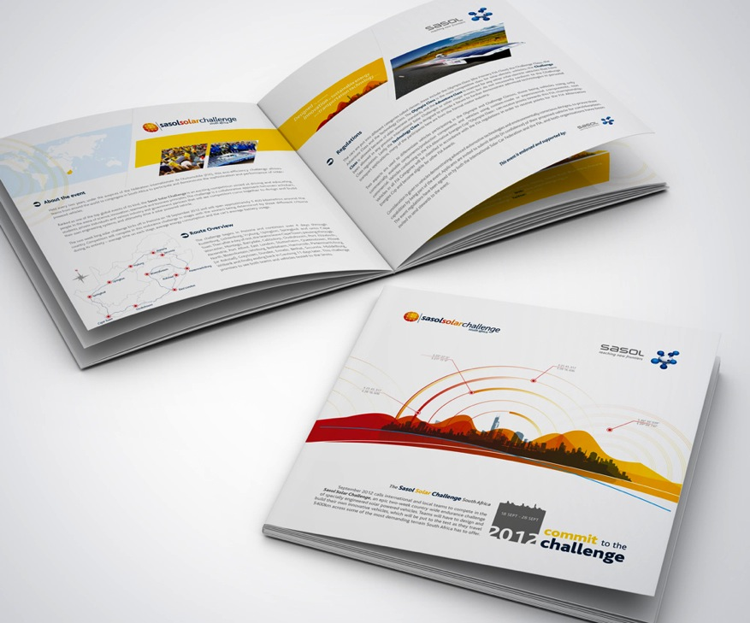

Appendix 1.2 / 附件1.2

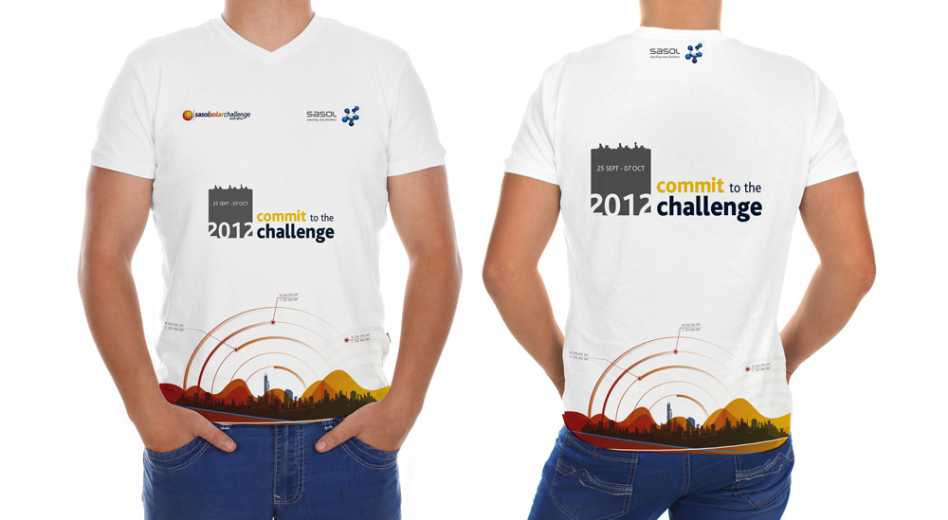

Appendix 1.3 / 附件1.3
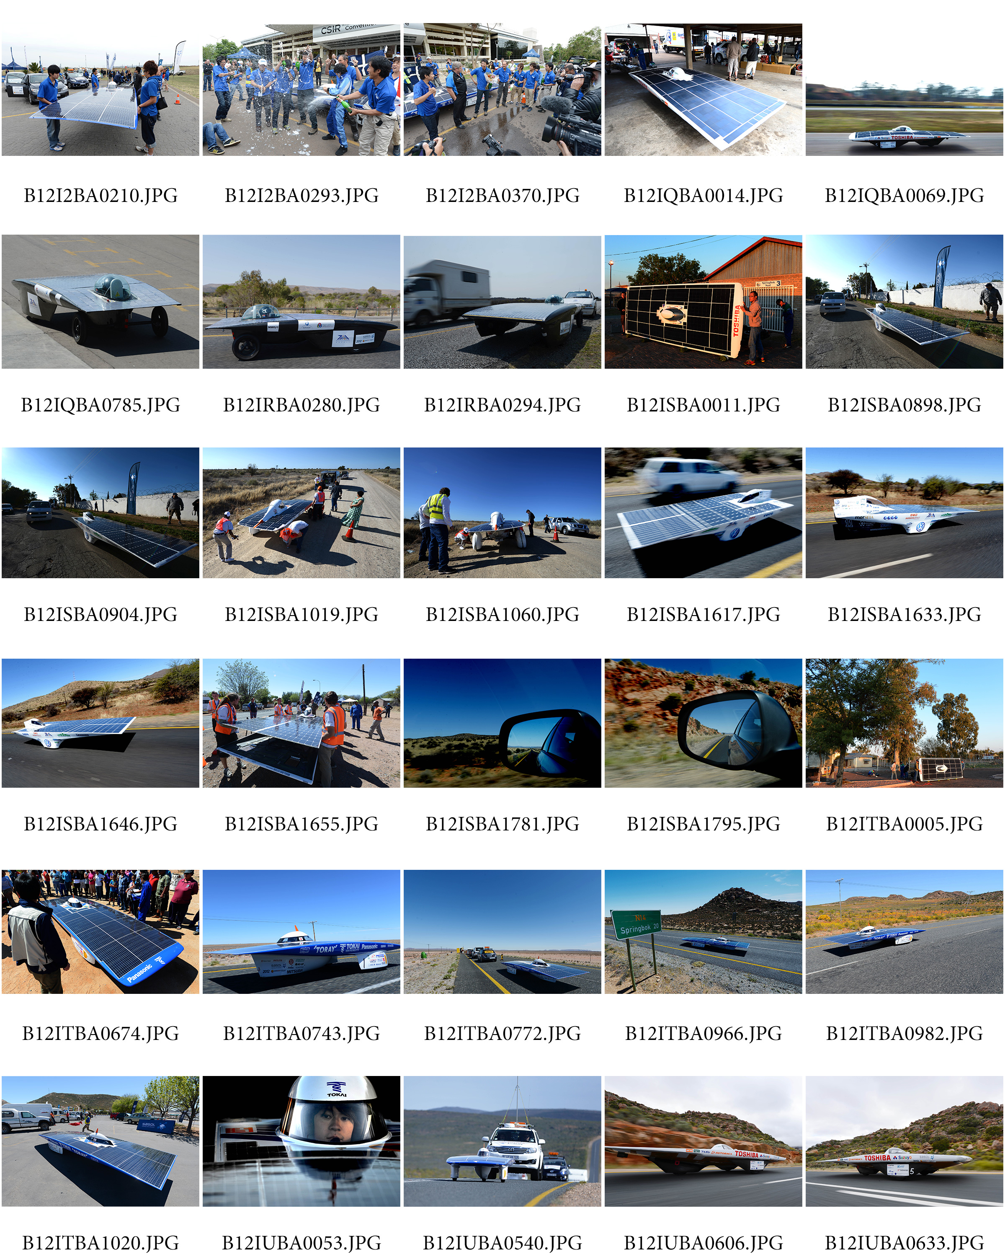

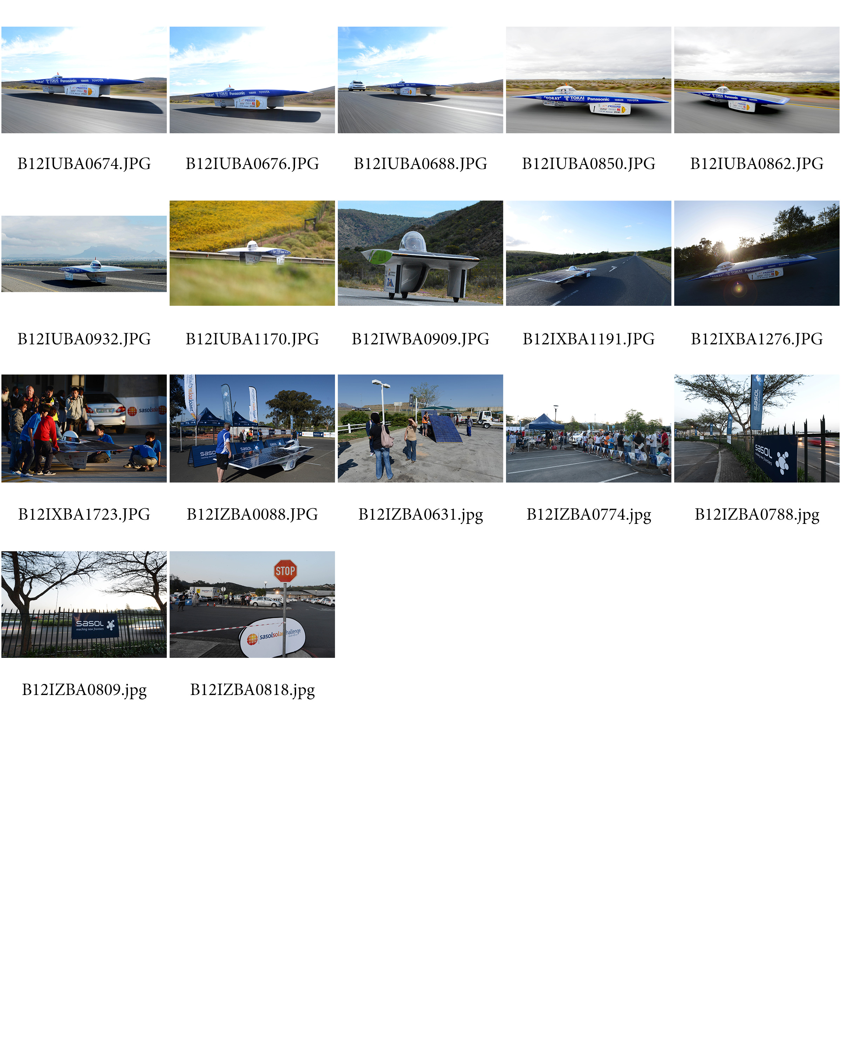

Appendix 1.4 / 附件1.4

